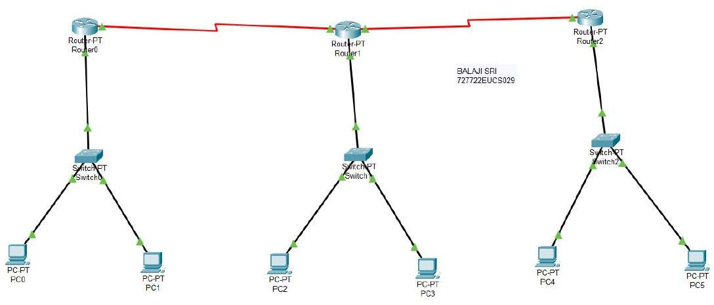

# 





### 727712EUC902J



FCG





### PO-PT

F'üï PC-PT

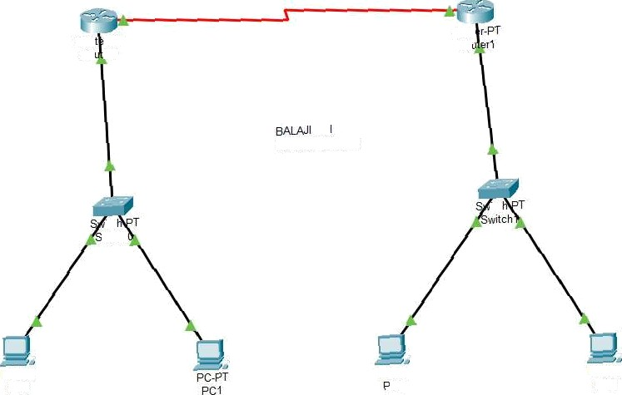

Row r-PT

Ro .er0

Rout

SR

727722EUCS029

itc

.witch

pC-F'T PCO

PIPT

’C2

PC-PT

# PTPT PC4

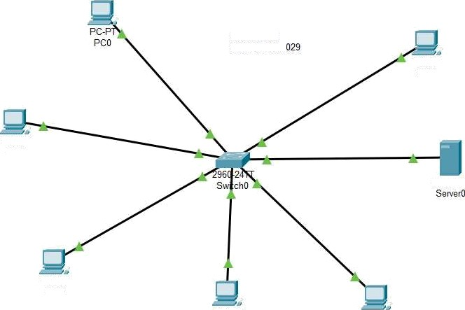

BALAJI SRI 727722EUCS

PC-PT PC3

PC-PT PC1

Server-PT

PC-PT PC2

PC-PT

pgç

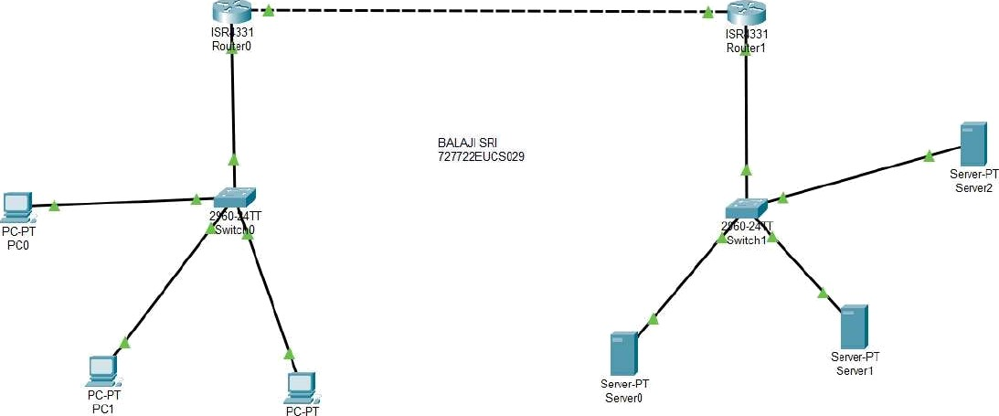

PC2

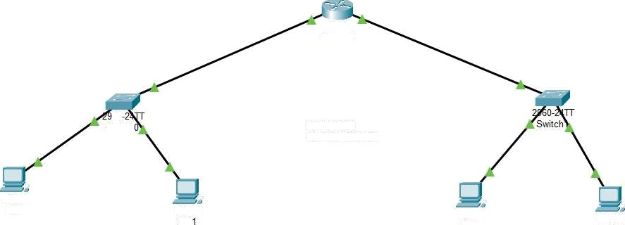

1941

Router0

60

Switch

BALAJI SRI 727722EUCS029

PC-PT PCO

PC-PT

PC-PT PC2

PC-PT PC3

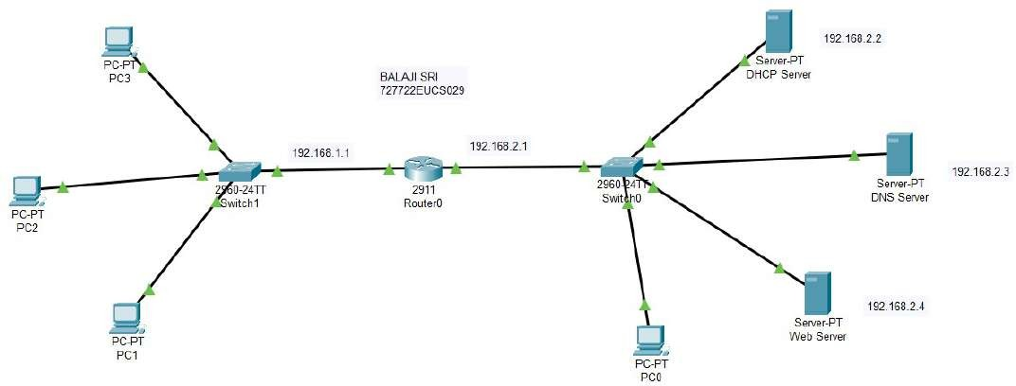

*R4331

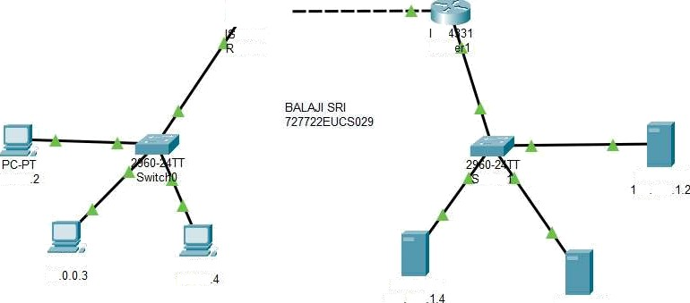

outer0

SR

Rout

1 0.0.0

## Sewer-PT 92 168

F'C-PT

1 0 10.0.0

Senær-PT

192168 Sewer-PT

# 192.168.1.3

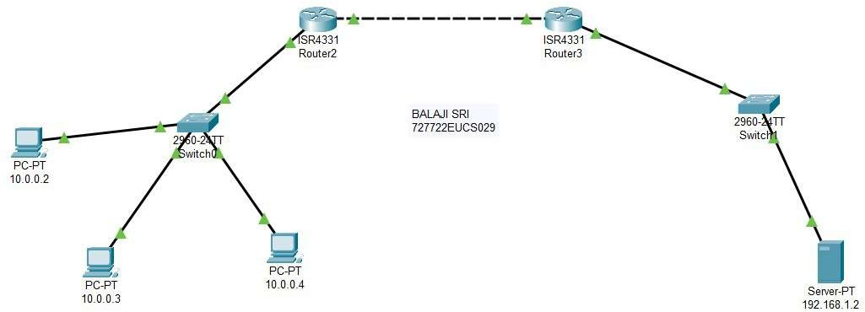

CONFIGURE 9IYłART HOME NEMOPK

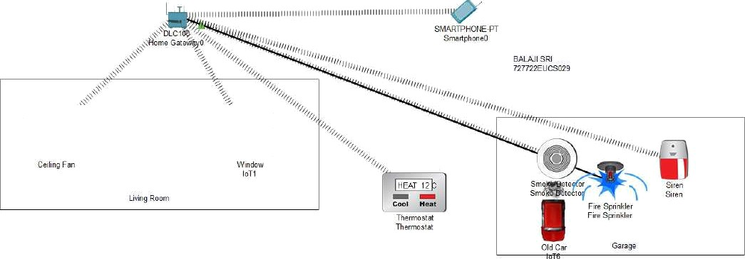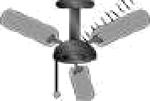

Physio al Config Deskto Programming Attrbutes

<” > URL fittp”//192 168 1 2 Stop

## COMPUTER WT\VORKS

727722EUCS029 BALAJI SRI

40002

10.0.0.3 100“,

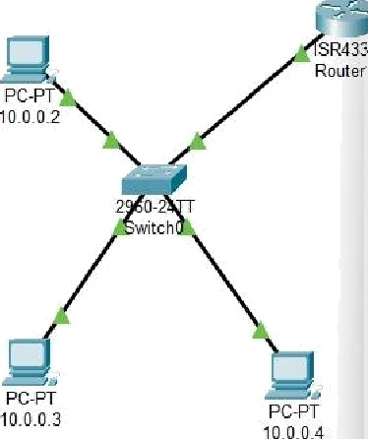

Physical Conâg 3eruces Desktop P rogramming A1tribuf es